**DAILY ONLINE ACTIVITIES SUMMARY**

|  |  |  |  |  |  |  |  |  |
| --- | --- | --- | --- | --- | --- | --- | --- | --- |
| **Date:** | **2/6/2020** | | | | | **Name:** | **Banish M G** | |
| **Sem & Sec** | **8th Sem** | | | | | **USN:** | **4AL16CS020** | |
| **Online Test Summary** | | | | | | | | |
| **Subject** | | **-------** | | | | | | |
| **Max. Marks** | | **----** | | **Score** | | | **------** | |
| **Certification Course Summary** | | | | | | | | |
| **Course** | **RPA** | | | | | | | |
| **Certificate Provider** | | | **RPA** | | **Duration** | | | **3 hrs** |
| **Coding Challenges** | | | | | | | | |
| **Problem Statement:**  1.   Given an array of positive integers. Write a C Program to find inversion count of array. | | | | | | | | |
| **Status:COMPLETED** | | | | | | | | |
| **Uploaded the report in Github** | | | | | **yes** | | | |
| **If yes Repository name** | | | | | B**anish_MG** | | | |
| **Uploaded the report in slack** | | | | | **yes** | | | |

Online Test Details: (Attach the snapshot and briefly write the report for the same)

Certification Course Details: (Attach the snapshot and briefly write the report for the same)

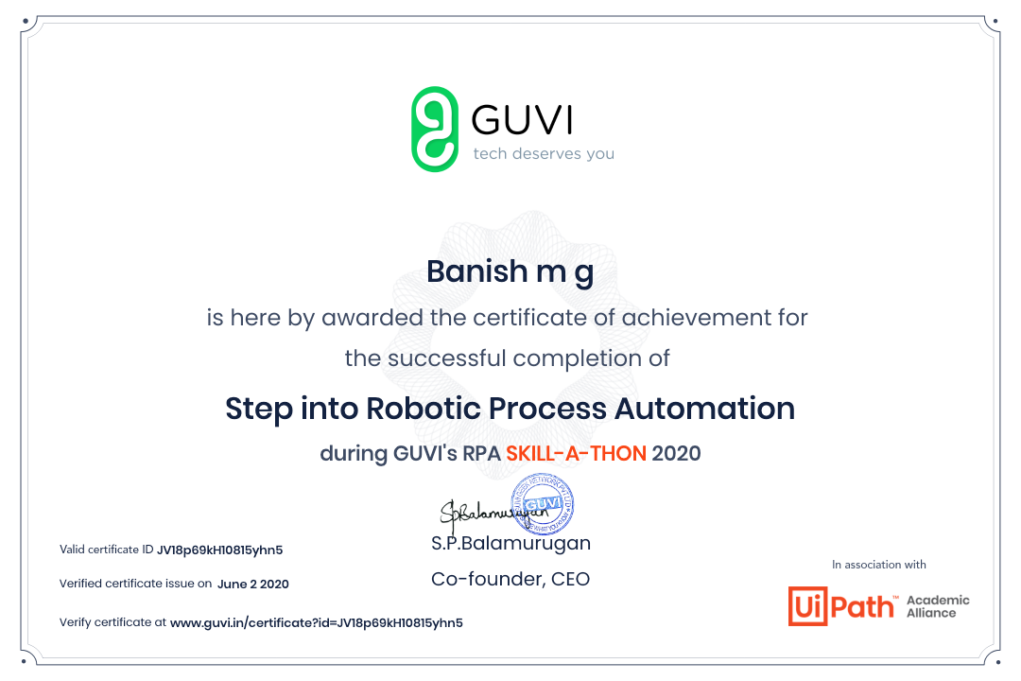

Coding Challenges Details: (Attach the snapshot and briefly write the report for the same)

Given an array of positive integers. Write a C Program to find inversion count of array.

#include <stdio.h>

int getInvCount(int arr[], int n)

{

int inv_count = 0;

for (int i = 0; i < n - 1; i++)

for (int j = i + 1; j < n; j++)

if (arr[i] > arr[j])

inv_count++;

return inv_count;

}

int main()

{

int arr[100],i=0,n=0;

printf("enter the number of elements");

scanf("%d",&n);

printf("enter the array");

for(i=0;i<n;i++)

{

scanf("%d",&arr[i]);

}

int count = getInvCount(arr, n);

printf(" Number of inversions are %d",count);

return 0;

}